# VMware network configuration

Zx was here <3

|  |  |  |
| --- | --- | --- |
| VM Name(Zip file) | IP address | Subnet |
| VM_CRONY_ZHAL | 192.168.109.50 | 192.168.109 |
| VM_2_ZHAL | 192.168.136.100 | 192.168.136 |

Assign both KALI VM and Challenge VM have the same subnet.

What it should look like after assigning all of them:

**KALI VM**

|  |  |
| --- | --- |
| Network Adapter | Subnet Address |
| VMnet1 (Example) | 192.168.109 |
| VMnet2 (Example) | 192.168.136 |

**Challenge VM 1 (VM_CRONY_ZHAL)**

|  |  |
| --- | --- |
| Network Adapter | Subnet Address |
| VMnet1 (Example) | 192.168.109 |

**Challenge VM 2 (VM_2_ZHAL)**

|  |  |
| --- | --- |
| Network Adapter | Subnet Address |
| VMnet2 (Example) | 192.168.136 |

**⬇️ Steps below ⬇️**

Instructions

*Note: Repeat steps for VM2*

1. Under VMware go to – Edit> Virtual Network Editor…

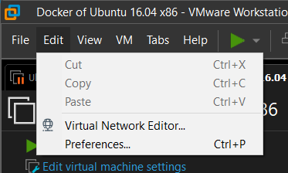

1. Next either “Add Network” or select unused existing VMnet

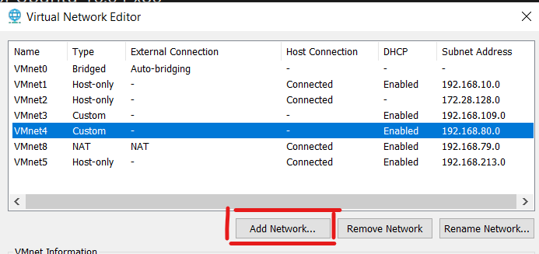

1. Change to these settings under VMnet

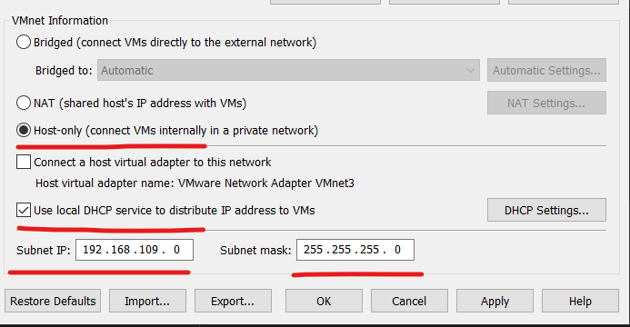

1. Ensure that under DHCP settings, Starting IP address does **not** cover ip address with 192.168.109.50

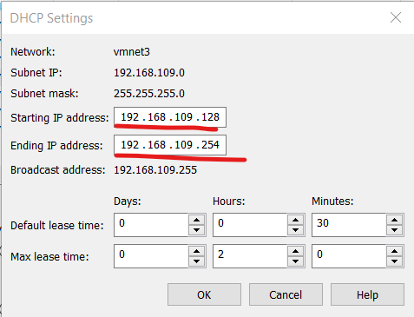

1. Go to VM’s setting

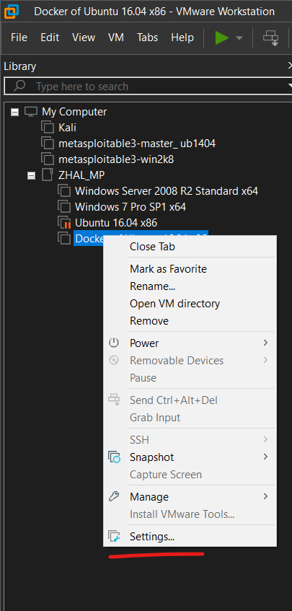

1. Assign according to the newly/changed VMnet number (Ensure your Victim VM only has 1 Network Adapter)

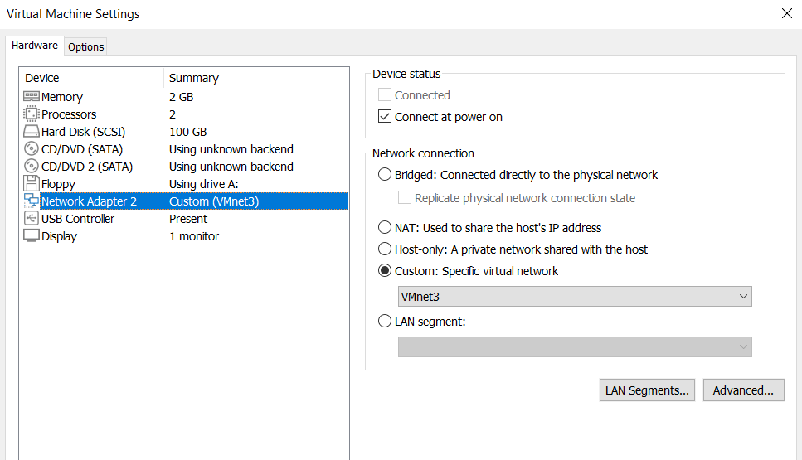

1. Your KALI should look like this after setting up (Two VMnet for separate VM)

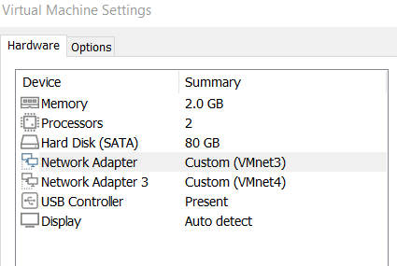

1. Turn on the Challenge VM and leave it be

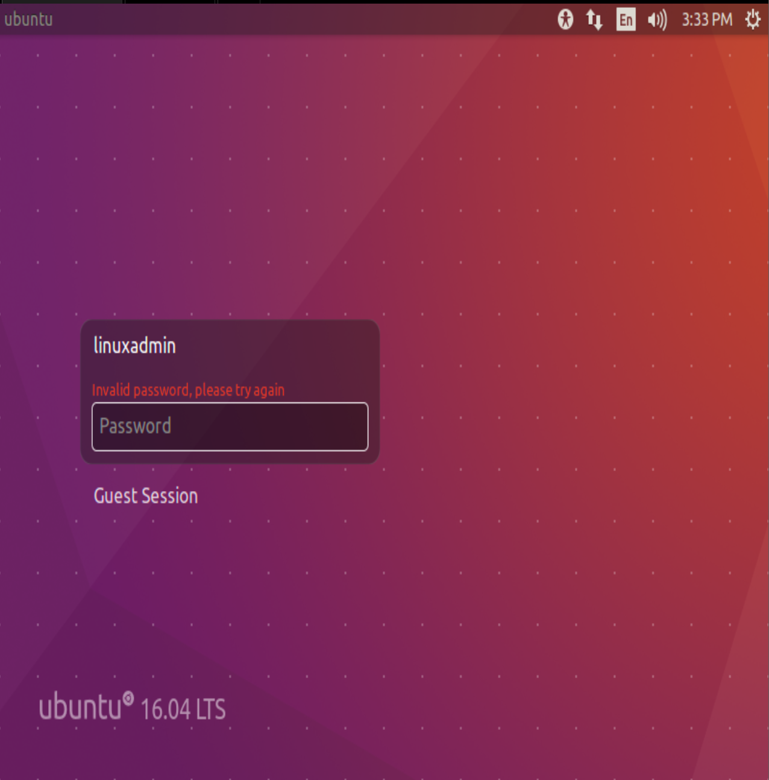

1. Wait at least 60sec for the container to boot before using ping to test if the connection works. (If it works you then you are ready to hack 8D)

